**Tools:**

Python

ARCH

Statsmodels

**Procedure built:**

Optimize: GARCH model: user can choose to iterate through different ARIMA models taking lowest AIC

Fit: GARCH: data applied to specified model

Predict: user can choose to use analytic or simulated forecasts

**Data:**

SPX 1/1/2000 – 6/8/2018 daily

VX1 2016 onward

Predict 1 day forecast from 1/1/2016 onward

**GARCH(1,1)**

Constant Mean - GARCH Model Results

====================================================================================

Dep. Variable: Close R-squared: -0.001

Mean Model: Constant Mean Adj. R-squared: -0.001

Vol Model: GARCH Log-Likelihood: -6263.62

Distribution: Standardized Student's t AIC: 12537.2

Method: Maximum Likelihood BIC: 12569.4

No. Observations: 4637

Date: Mon, Jun 11 2018 Df Residuals: 4632

Time: 22:31:45 Df Model: 5

Mean Model

============================================================================

coef std err t P>|t| 95.0% Conf. Int.

----------------------------------------------------------------------------

mu 0.0672 1.067e-02 6.300 2.979e-10 [4.631e-02,8.814e-02]

Volatility Model

============================================================================

coef std err t P>|t| 95.0% Conf. Int.

----------------------------------------------------------------------------

omega 9.6820e-03 3.081e-03 3.143 1.674e-03 [3.644e-03,1.572e-02]

alpha[1] 0.1027 1.325e-02 7.754 8.935e-15 [7.675e-02, 0.129]

beta[1] 0.8953 1.295e-02 69.116 0.000 [ 0.870, 0.921]

Distribution

========================================================================

coef std err t P>|t| 95.0% Conf. Int.

------------------------------------------------------------------------

nu 6.5809 0.659 9.984 1.787e-23 [ 5.289, 7.873]

========================================================================

Covariance estimator: robust

Next N days forecast variance:

h.01 h.02 h.03 ... h.08 h.09 h.10

Date ...

2018-06-08 0.493867 0.502557 0.511229 ... 0.554331 0.562899 0.57145

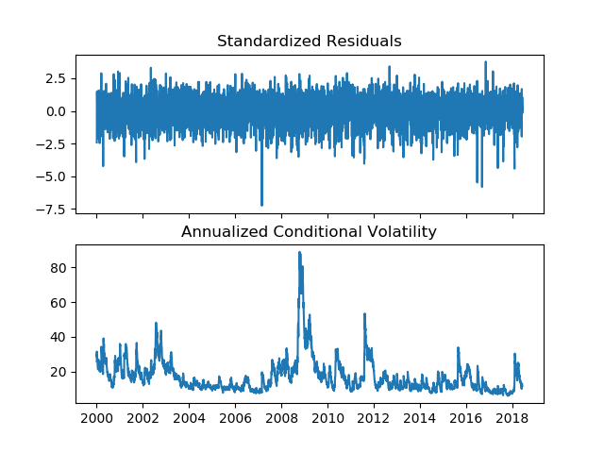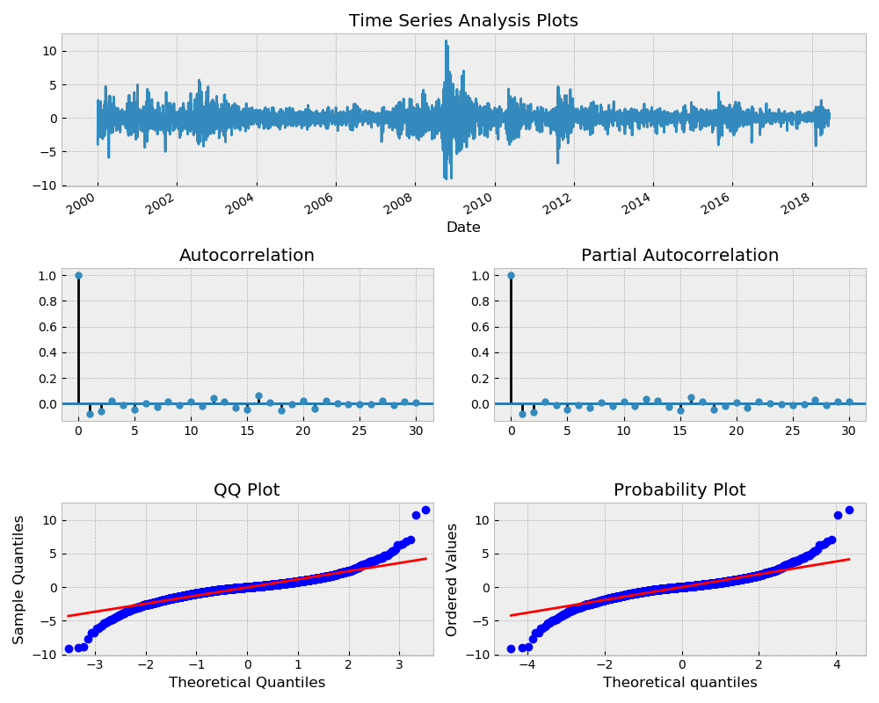

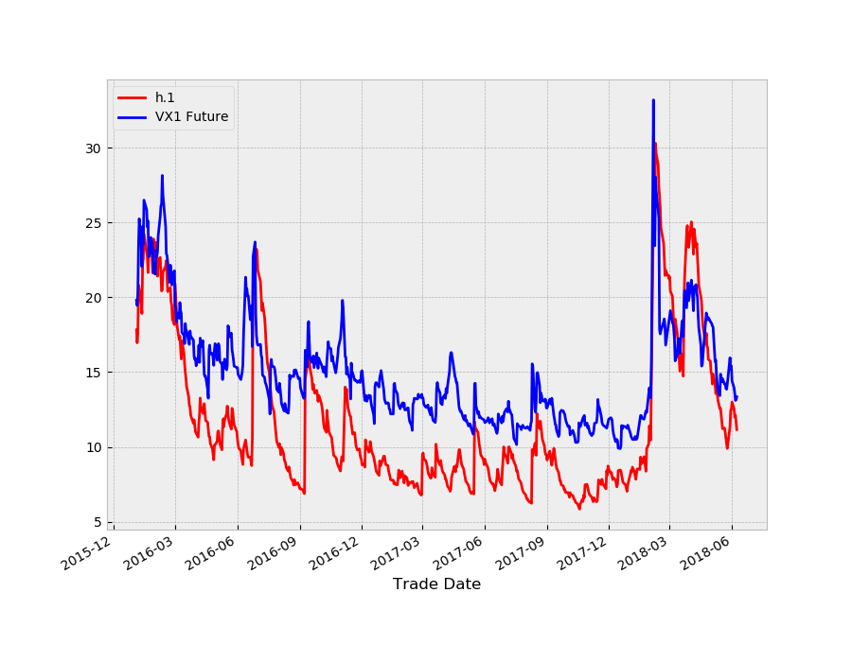

**GARCH(4,3)**

Constant Mean - GARCH Model Results

====================================================================================

Dep. Variable: Close R-squared: -0.002

Mean Model: Constant Mean Adj. R-squared: -0.002

Vol Model: GARCH Log-Likelihood: -6255.01

Distribution: Standardized Student's t AIC: 12530.0

Method: Maximum Likelihood BIC: 12594.4

No. Observations: 4637

Date: Mon, Jun 11 2018 Df Residuals: 4627

Time: 22:46:07 Df Model: 10

Mean Model

============================================================================

coef std err t P>|t| 95.0% Conf. Int.

----------------------------------------------------------------------------

mu 0.0693 1.074e-02 6.456 1.079e-10 [4.827e-02,9.035e-02]

Volatility Model

============================================================================

coef std err t P>|t| 95.0% Conf. Int.

----------------------------------------------------------------------------

omega 0.0375 1.343e-02 2.795 5.193e-03 [1.121e-02,6.384e-02]

alpha[1] 0.0451 1.784e-02 2.528 1.149e-02 [1.013e-02,8.006e-02]

alpha[2] 0.1451 4.094e-02 3.544 3.939e-04 [6.485e-02, 0.225]

alpha[3] 0.0835 3.494e-02 2.391 1.680e-02 [1.506e-02, 0.152]

alpha[4] 0.0605 7.882e-02 0.768 0.443 [-9.396e-02, 0.215]

beta[1] 0.0000 0.298 0.000 1.000 [ -0.584, 0.584]

beta[2] 0.0000 0.499 0.000 1.000 [ -0.977, 0.977]

beta[3] 0.6555 0.229 2.868 4.131e-03 [ 0.208, 1.104]

Distribution

========================================================================

coef std err t P>|t| 95.0% Conf. Int.

------------------------------------------------------------------------

nu 6.5347 0.654 9.998 1.551e-23 [ 5.254, 7.816]

========================================================================

Covariance estimator: robust

Next N days forecast variance:

h.01 h.02 h.03 ... h.08 h.09 h.10

Date ...

2018-06-08 0.484493 0.474567 0.531161 ... 0.553633 0.580212 0.57161

Resources:

<http://arch.readthedocs.io/en/latest/univariate/univariate.html>

<http://www.blackarbs.com/blog/time-series-analysis-in-python-linear-models-to-garch/11/1/2016>

<https://tomaugspurger.github.io/modern-7-timeseries>

<https://machinelearningmastery.com/arima-for-time-series-forecasting-with-python/>

<http://www.seanabu.com/2016/03/22/time-series-seasonal-ARIMA-model-in-python/>